Client Portal Update
- Welcome message
Welcome to CapitalQuest Funding!
We’re excited to have you on board! At CapitalQuest Funding, our mission is to help business owners like you secure the capital needed to grow and scale your business. Our process is designed to maximize your approval odds by optimizing your credit profile to align with what banks look for when approving high-limit business credit.

What You Can Expect from Us:
Personalized Credit Optimization – We analyze your credit profile in detail and make strategic adjustments to position you for the highest funding approvals possible.
Strategic Bank Matching – Not all banks approve the same way. We structure your applications to match the specific criteria each lender looks for, ensuring the best results.
Step-by-Step Guidance – From credit analysis to funding applications, we guide you through every stage, making sure you understand what’s happening at each step.
Ongoing Support – Whether it's credit adjustments, application strategies, or funding insights, we’re here to ensure your success.
Your journey to securing business funding starts now! Click Next to sign your contract and move forward with the process.
(Please align title to center)

- Please use address fields in the app should follow the United States address format for both personal and business addresses. (PLEASE REMOVE ADDRESS 2)

USA Address Format:
Street Address: [House/Building Number] + [Street Name] + [Apartment/Suite/Unit # (if applicable)]
City: [City Name]
State: [State Abbreviation (e.g., CA, NY, TX)]
ZIP Code: [5-digit or 9-digit ZIP Code]
EXAMPLE BELOW
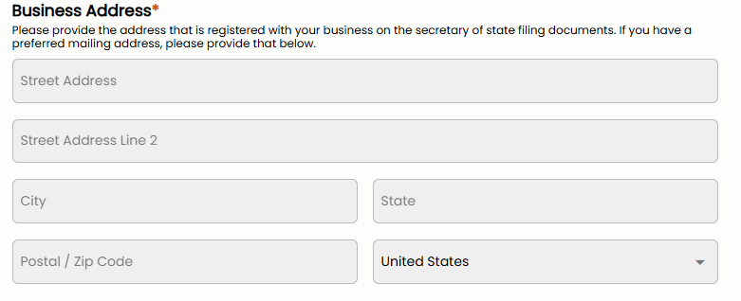

- Privacy Policy & Terms of Service Placement
  - Clients should be required to review and accept the Privacy Policy and Terms of Service immediately upon logging into their account.
  - This must happen before they sign the contract or proceed with any other actions.
4. Contract Viewing Before Signing
- Change the flow so that clients view the contract first before entering their name, business info, and signing.
- Ensure the contract is readable before requiring any input.
- Clients should only proceed to signing after fully reviewing the document
5. Add All Banks Under Funding Details
- Ensure that all banks we apply with are listed in the Funding Details section.
- Wells Fargo
- PNC Bank
- Bank of America
- Chase
- Amex
- US Bank
- Truist
- Marcus by Goldman Sachs
- Key Bank
- BMO Harris
- Citizens bank
- M&T Bank
6. Funding Process Order Update
- Change the Funding Process steps to follow this exact order:
  - Contract Signed
  - Onboarding Form Completed
  - Turn Off Fraud Alerts
  - Pay Down Utilization
  - Add Tradeline (if needed)
  - Remove Inquiries
  - Open Business Account
  - Cleared for Funding
  - Funded
7. Credit Score Overview Update
- Ensure the maximum credit score displayed is 850.
- Update credit score ranges as follows:
  - Poor: 300-579
  - Fair: 580-669
  - Good: 670-739
  - Very Good: 740-799
  - Excellent: 800-850
8. Client Chat System:
  - Ensure that every client has a chat with me and my business partner, Ali.
  - Clients should not be able to start a new chat with anyone else.
  - Only Ali and I should have the ability to communicate with them through the chat system.
9. Disqualification Page
- Create a dedicated disqualification page that appears if a client is disqualified.
- This page should:
  - Display a message explaining the disqualification reason.
  - Provide steps the client can take to become eligible.
  - Be customizable, so we can manually enter the reason for disqualification.
  - Restrict access to the portal—once disqualified, the client should only see this page and nothing else.
Dear [Client’s Name],
Thank you for taking the time to apply with us. We truly appreciate the opportunity to assist you in your journey toward securing funding for your business.
After carefully reviewing your application and credit profile, we regret to inform you that at this time, you do not meet the necessary qualifications to proceed with our funding process.
Reason for Disqualification:
[Insert specific reason here]
We understand that this may be disappointing, but we want you to know that this is not the end of your journey. Our goal is to help you position yourself for success, and we’re here to provide guidance on what steps you can take to improve your profile.
What You Can Do Next:
- [Insert actionable step #1]
- [Insert actionable step #2]
- [Insert actionable step #3]
If you would like to work on improving your qualifications, we are happy to provide recommendations tailored to your situation. Please reach out if you’d like to discuss a plan to get you back on track.
We appreciate your trust in us and look forward to assisting you in the future. If you have any questions, please don’t hesitate to reach out.
Best regards,
CapitalQuest Funding Team

10. Onboarding Form Updates
- Remove "Address Line 2." from personal address and business
- Change “region” to “state”
Example below:

- Step 1 (Personal Side):
  - Add "Current Personal Bank Relationships."
- Step 2 (Business Side):
  - At the end, "PIN" should have its own answer field.
  - "Security Question" should have its own answer field.
- Credit Accounts in the Last 6 Months:
  - Personal credit accounts should be listed in Step 1 (Personal Side).
  - Business credit accounts should be listed in Step 2 (Business Side).
- Step 3:
  - EIN NUMBER FORMAT ##-#######
  - Phone number: ###-###-####
  - Social security: ###-##-####
Basically, anything on the onboarding form that is a personal question should be on step one which is for personal and anything that a business related question should be on business sidestep 2.

At CapitalQuest Funding, your privacy is important to us. This Privacy Policy outlines how we collect, use, and protect your personal information.

- Information We Collect
  - Personal Identifiers: Name, phone number, email, and address.
  - Financial Data: Credit history, banking relationships, and funding details. Login Credentials: Username and password for accessing our portal.
- How We Use Your Information
  - We use your information to: Assess creditworthiness and develop funding strategies. Submit and track funding applications with banks. Provide updates on your funding status via our portal. Improve our services and customer experience.
- How We Protect Your Information
  - We implement encryption and secure storage to protect client data. Access to sensitive data is restricted to authorized personnel only. Client data is automatically deleted once the funding process is completed.
- Data Sharing & Third-Party Disclosure
  - We do not sell, rent, or share your personal data with third parties except:
    - Banks & Financial Institutions: For the purpose of funding applications.
    - Credit Bureaus: For retrieving credit reports with your consent.
- Data Retention & Deletion Policy
  - All personal and financial data will be permanently deleted once the funding process is complete.If legally required, we may retain minimal records for compliance purposes.
- Your Rights & Choices
  - You have the right to:Request access to your personal data. Request deletion of your information from our systems. Opt out of non-essential communications.
- Changes to This Policy
  - We may update this Privacy Policy from time to time. Clients will be notified of significant changes via email or the client portal.
- Contact Information
  - For any questions regarding our Terms or Privacy Policy, contact us at: +1 (800) 773-3776

